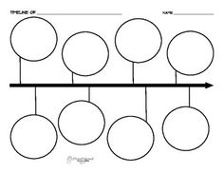

The Mongol armies conquered CA; destroy many cities. Empire falls; Uzbeks, Kazakhs, Turkmens move in the region

Russian revolution, formed a Soviet government in CA. Turn the land into republics. Huge irrigation/cotton production

Soviet Union government/economy collapsed. CA republics became an independent country

Russians invade CA. Built railroads, expanded cotton, oil. The people resented such rule

CA trade declined. Region became isolated and poor

Arab armies invade brought a new religion-Islam-to CA. Build beautiful mosques

**History of Central Asia (CA)**

Turkic speaking nomads from northern Asia came to CA. For the Silk Road

Merchants traveled the China route-traded with Europe gold/wool for spices and silk

**1991**

**1917**

**1800s**

**1500**

**1200s**

**700s**

**AD 500**

**100 BC**